DRAFT
Crop simulation model

General model

Crop growth and development is simulated in a dynamic manner. The major processes considered are crop ontogeny, crop area development, crop biomass buildup and dry matter transfer to storage organs.
The crop model has a daily time step, and climate variables required are: mean air temperature, precipitation, global radiation and potential evaporation <Skriv et eller andet sted at den potentielle fordampning ganges med en afgrødeafhængig faktor>.
The only nutrient presently affecting modelled growth rate is nitrogen.
The developmental phase of a crop is controlled by temperature sums, which are calculated according to eq. (2.a) by summing mean air temperature above a specified threshold.

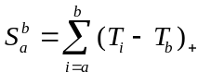 (2.a)

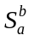 = the temperature sum from day a to b (°C)
= mean air temperature at day i (°C)
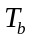 = base temperature (°C)

The subscript (+) denotes that only positive values are considered.

The date 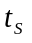 when a specified temperature sum demand S is fullfilled is given by:

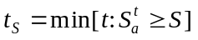 (2.b)

The phenological development is simulated by growth phases, the number of growth phases varies among the crops. The current phase is given by F, and each phase has a corresponding temperature sum 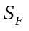. When the date is reached, F is incremented by one.

Table 2.3.i. Names of growth phases in spring crops.
F S.Barley Peas

1 germination germination
2 linear leaf linear leaf
growth growth
3 vegetative vegetative
4 vegetative flowering
elongation
5 heading unused
anthesis
6 grain filling pod filling
7 ripening ripening
8 ready for ready for
harvest harvest

Table 2.3.j. Names of growth phases in winter crops.
F W.Wheat W.Barley W.Rape

1 germination germination germination
2 linear leaf linear leaf linear leaf
growth growth growth
3 vegetative vegetative vegetative
4 vegetative vegetative vegetative
elongation elongation elongation
5 elongation elongation flowering
/heading /heading
6 grain filling grain filling pod filling
7 ripening ripening ripening
8 ready for ready for ready for
harvest harvest harvest

The 1st of March the temperature sum is set to zero for winter crops, and F will not exceed 3 before this date.
The model behaves under the assumption that no further development takes place at at phase 8.

Table 2.3.k. Names of growth phases in grass crops.
F Ryegrass

1 germination
2 linear leaf
growth
3 vegetative

Within each daily update the following actions are taken in specified order:
1. Information for the soil module is transferred.
2. Nitrogen uptake and transpiration ratio from the soil module is transferred to the crop module.
3. In case of a nitrogen fixating crop the actual fixation is computed. As the crop only is updated once a day, this fixation is computed on the basis of yesterdays potential fixation.
4. The thermal age is updated.
5. Net dry matter increase is computed.
6. In case of a nitrogen fixating crop, the eventual energetic cost of fixation is subtracted from net dry matter increas.
7. In case of a nitrogen fixating crop, the maximum fixation is computed.
8. Some of the dry matter is allocated to the root.
9. A new root distribution is computed.
10. An eventual dry matter transfer to storage organs is computed.
11. The remaining net dry matter increase is transferred to the vegetative top of the crop.
12. New values for green and yellow crop area is computed.

<Det skal anføres at respiration ikke udregnes, der regnes i stedet med en mindre lysudnyttelse - referencer >

Leaf area development

Crop area is described by green crop area index 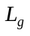, and yellow crop area index 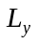. It is handled as a “one-leaf model”, and no dry matter is allocated specificly to the leaf area.The area index is the one-sided area of resp. green and dead crop parts per unit ground area. The total crop area index L is computed by summation:

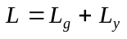 (2.k)

After emergence the green crop area is descibed by (2.d).

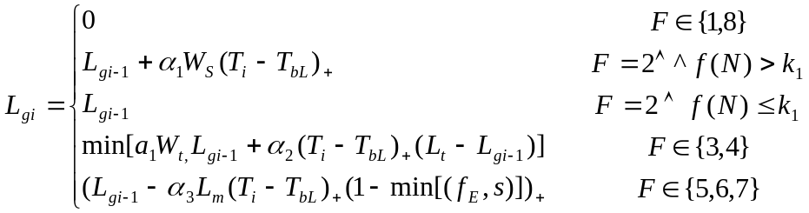 (2.d)

The green crop area is zero before emergence (F = 1) and is assumed to be zero again at ripeness (F = 8).
In the linear growth phase (F = 2) the daily increase in green crop area is proportional to the seed dry matter and temperature above a threshold.
In phases 3 and 4 the green crop area is assumed to increase following a target function. The target is a function of top nitrogen and dry matter, eq. 2.X. The green crop area is potentially limited by top dry matter.
In phases 5 to 7 only decline in green crop area is assumed. The decline function is enhanced by water stress, but contains a minimum senescense.

The daily change in green crop area is simply:

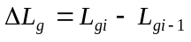 (2.A)

and the referred functions are:

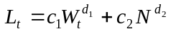 (2.X)

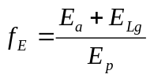 (2.m)

For the function 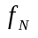 see eq. (2.q), section 2.3.4.
The value of 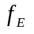 is computed by the “soil “ module, see XX.
The development in the yellow leaf area index is calculated as follows

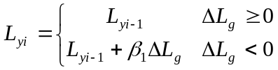 (2.z)

Note that this equation only has an effect in phases 5 to 7, the only phases where the model mediates a negative development in green leaf area index.

 = seed dry matter (g m⁻²)
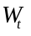 = top dry matter (g m⁻²)
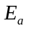 = actual transpiration (mm)
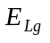 = evaporation from water intercepted on green leaves (mm)
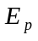 = potential evaporation from the green leaves (mm)
, 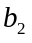 = constants (g m⁻²)
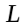 = total leaf area index
= green leaf area index
. = yellow leaf area index
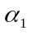 = leaf area development parameter (m² g⁻¹ °C⁻¹)
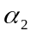,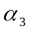 = leaf area development parameters (°C⁻¹)
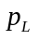 = power constant
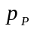 = power constant
= extinction coefficient
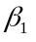 = coefficient
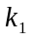 = minimum N function value for leaf growth in linear growth phase
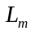 = maximum green crop area achieved
= minimum green crop area decline at phase 5 and higher

Root development

At crop emergence the root depth is set to an initial value (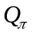). Thereafter the development in root depth is described by (2.e) after Jakobsen (1976).

(2.e)

 = root depth (m)
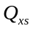 = maximal root depth for present soil (m)
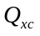 = maximal root depth for present crop (m)
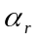 = root growth coefficient (m °C⁻¹⁾
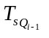 = soil temperature at root depth for time i-1 (°C⁻¹)

The vertical distribution of root density (D) is described by (2.f), and the total root length is given by (2.g), after Gerwitz & Page (1974).

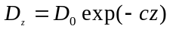 (2.f)

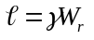 (2.g)

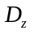 = root density (m m⁻³) at depth z
= depth (m)
= root density distribution parameter (m⁻¹)
= total root length (m m⁻²)
= specific root length (m m⁻²)
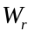 = root dry matter (g m⁻²⁾

Under the assumption that

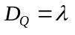 (2.h)

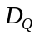 = root density at maximum root depth Q (m m⁻³)
= crop specific root density constant (m m⁻³)

the root density distribution parameter c can be calculated iteratively from (2.g) and the integration of (2.f).

When the root length is small, defined as fullfillment of (2.i), the root density is assumed to decrease linearely (2.j) (Hansen et al 1990).

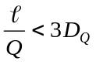 (2.i)

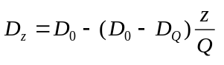 (2.j)

Nitrogen in the crop

Initially the nitrogen content N (g m⁻²) is set to the nitrogen content in the seed (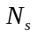).
In the present model it is assumed that the crop will take up available nitrogen, until the nitrogen content N has risen to a point where 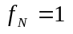.

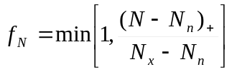 (2.q)

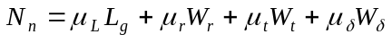 (2.r)

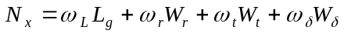 (2.s)

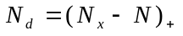 (2.t)

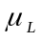 = constant for calculating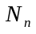 (g m⁻²)
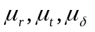 = constants for calculating
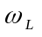 = constant for calculating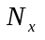 (g m⁻²)
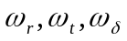 = constants for calculating
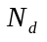 = Nitrogen demand (g m⁻²)

The daily nitrogen uptake is calculated by the soil module (se chapter X), and in order to perform this calculation root length and density distribution and N-demand is passed to the soil module.

The allocation of nitrogen between compartments in the model are give by the following equations:

(2.F)

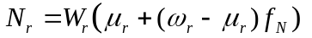 (2.G)

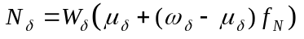 (2.H)

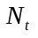 = nitrogen in top (g m⁻²)
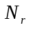 = nitrogen in root (g m⁻²)
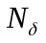 = nitrogen in storage organs (g m⁻²)

Water and nitrogen uptake

The main part of the computation of water and nitrogen uptake is performed by the “soil” module, see XX. Neccesary information to pass on to this module are the following parameters:

= Water potential at wilting point (pF)
= root radius (mm)
= Nitrogen demand (g m⁻²) given by (2.t)
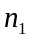 = nitrate uptake rate (g m⁻¹ d⁻¹)
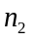 = ammonium uptake rate (g m⁻¹ d⁻¹)
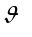 = interception capacity (mm m⁻²) given by (2.A)
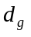 = fraction of potential evapotranspiration attributed to green leaves. Given by (2.B)
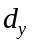 = fraction of potential evapotranspiration attributed to yellow leaves. Given by (2.D)
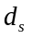 = fraction of potential evapotranspiration attributed to the soil. Given by (2.C)

Furthermore the vertical distribution of the root density given by (2.i) or (2.f) is passed to the “soil” module.

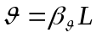 (2.A)

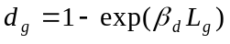 (2.B)

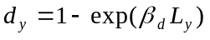 (2.C)

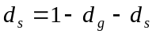 (2.D)

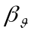 = coefficient (mm)
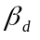 = coefficient

The “soil” module supplies the “crop” module with values for (see 2.m) and the uptake of nitrogen 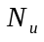. Total nitrogen in crop N is updateted as follows

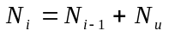 (2.I)

The boundaries for 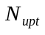 are given by

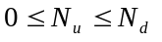 (2.J)

Dry matter accumulation

At sowing time, the dry matter W (g m⁻²) in the crop is set to equal dry matter in the seed, .
Half the dry matter from the seed is assigned to top dry matter (), and the other half to root dry matter ().

Total dry matter is given as

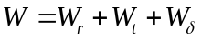 (2.u)

= Dry matter in root (g m⁻²)
= Dry matter in top (g m⁻²)
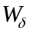 = Dry matter in storage organs (g m⁻²)

Dry matter accumulation is calculated as

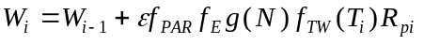 (2.v)

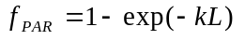 (2.o)

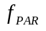 is the fraction of intercepted radiation calculated from Beer’s law.

The temperature function 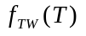is taken from Hansen et al (1990)

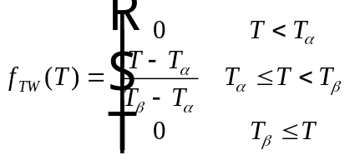 (2.w)

The effect on nitrogen status on radiation use efficiency was estimated from response functions presented in graphs by Sinclair & Horie (1989)

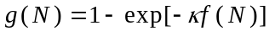 (2.X)

= radiation use efficiency (g MJ⁻¹)
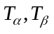 = Temperature limits (°C)
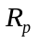 = Daily incident phosynthetic active radiation (MJ m⁻²). This variable is set to 48% of global radiation according to Hansen et al (1981).
= dimensionless constant

Dry matter partitioning

In the present model the dry matter is assumed to be divided into three compartments: the top (including leaves and structural parts), the root and storage organs. The dry matter is allocated or re-allocated into these three compartments.

The partitioning between root and top is

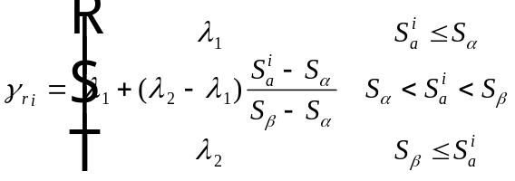 (2.x)

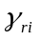 = fraction of dry matter production allocated to root on day i
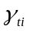 = fraction of dry matter production allocated to top on day i
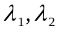 = partitioning parameters
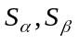 = temperature sums (°C)
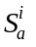 = temperature sum at day i using 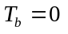 (see eq (2.a)). The temperature sum is set to zero at crop emergence.

The transfer of dry matter to the storage organs is simulated according to Amir & Sinclair (1991) and Spaeth & Sinclair (1985)

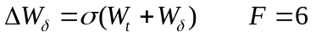 (2.y)

σ = harvest transfer coefficient

At harvest all the root matter is transferred to soil organic pools (see XX), and the whole top and storage organs are transferred to the “technics” module. Susequently any fraction of these matters can be returned to be added to the soil top denpending on the parameters in “fields” (see XX).

2.3.9 Irrigation

The water state of the soil is defined as

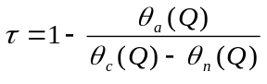 (2.E)

after Olesen & Plauborg 1995.

= water state (0-1)
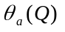 = plant available water (mm) at depth range 0-Q, see chapter X.
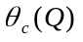 = water content at field capacity (mm) at depth range 0-Q, see chapter X.
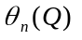 = water content at wilting point (mm) at depth range 0-Q, see chapter X.
Q = root depth (m)

If is below a critical level 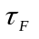, depending on growth phase F according to table 2.3.h, an irrigation of the field in question is performed.
Irrigation will only be performed if the “irrigation” option is set, see X.X, and only on sandy soils (JB 1-3).

Specific features

Nitrogen fixation

In the case of nitrogen fixating crops, the maximum or potential nitrogen fixation 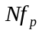is assumed to be proportional to the dry matter increase

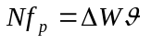 (2.X)

The actual or realized fixation 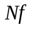 is given by

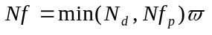 (2.X)

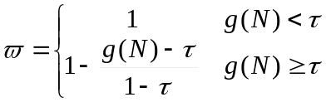 (2.X)

A fixation has an associated energetic cost, reducing the dry matter accumulation

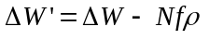 (2.X)

Grass model
The model for grass is different from the other crop models in that it operates with four ageclasses of leafs. More….

Beet and potato model
The beet and the potato has its storage organs below ground in the form of tubers. This affects the way certain outputs are calculated. Total aboveground biomass will in the case of beet and potato only be the vegetative biomass.

Parameter values
<Too be updated>

References

Anonymous. 1985. Internt notat. Jyndevad forsøgsstation. Afd for kulturteknik, Statens Planteavlsforsøg.

Amir, J. & Sinclair, T.R. 1991. A model of the temperature and solar-radiation effects on spring grown wheat growth and yield. Field Crop Res. 28, 47-58.

Gerwitz, S. & Page, E.R. 1974. An empirical mathematical model to describe plant root systems. J. Appl. Ecol. 11, 773-781.

Hansen, S., Jensen, H.E., Nielsen, N.E. & Svendsen, H. 1991. Simulation of nitrogen dynamics and biomass production in winter wheat using the Danish simulation model DAISY. Fert. Res. 27, 245-259.

Hansen, S., Jensen, S.E., Nielsen, N.E. & Svendsen, H.1990. DAISY - Soil Plant Atmosphere System Model. Miljøstyrelsen.

Hansen, S., Jensen, S.E. & Aslyng, H.C. 1981. Jordbrugsmeteorologiske observationer, statistisk analyse og vurdering 1955-1979. Hydroteknisk Laboratorium, Den Kgl. Veterinær og Landbohøjskole, København.

Jakobsen, B.F. 1976. Jord, rodvækst og stofoptagelse. In: Simuleret planteproduktion. Hydroteknisk Laboratorium, Den Kgl. Veterinær- og Landbohøjskole, København.

(Kiniry, J.R., Jones, C.A., O’Toole, J.C., Blanchet, R., Cabelguenne, M. & Spanel, D.A. 1989. Radiation use efficiency in biomass accumulation prior to grain-filling for five grain-crop species. Field Crop Res. 20, 51-64)

Madsen, H.B. & Holst, K. 1987. Potentielle marginaljorder. Marginaljorder og miljøinteresser. Miljøministeriets projektundersøgelser 1986. Teknikerrapport nr. 1.

Olesen, J.E & Plauborg, F. 1995. MVTOOL version 1.10 for developing MARKVAND. SP report no. 27, Vol. 3. Statens Planteavlsforsøg.

Symbol list

BROKKASSEN

